Test Plan Document For
KRISHAK

Made By:
Nancy Srivastava (2100290120109) 8B
Surabhi Agnihotri (2100290120169) 8C
Tushtee Singh (2100290120176) 8C
Kushagra Singh (2100290120099) 8B

Test Manager:
Mr. Harsh Khatter

Change Log
Version | Change Date | By | Description
001 | 04.12.2024 | Kushagra Singh | Initial Draft
002 | 11.12.2024 | Kushagra Singh | Complete Draft

1 Introduction 1
1.1 Scope 4
1.2 Quality Objective 5
1.3 Roles and Responsibilities 6

2 Test Methodology 9-18
2.1 Overview 10
2.2 Test Levels 10
2.3 Suspension Criteria and Resumption Requirements 13
2.4 Test Completeness 13

3 Test Deliverables 18-22

4 Resource & Environment Needs 18-22
4.1 Testing Tools 18
4.2 Test Environment 20

5 Terms/Acronyms 22-23

- Introduction
Krishak is an Affordable Farm Equipment Sharing Platform designed to help small-scale farmers access essential agricultural machinery through a digital sharing system. This platform leverages technology and collaborative sharing to reduce costs, improve productivity, and promote sustainable farming practices. By connecting farmers with available equipment, Krishak aims to address challenges like high ownership costs and limited access to machinery. This test plan outlines the platform's key features, functionalities, and objectives, ensuring a smooth and efficient user experience while meeting the needs of the farming community.

  - Scope
    - In Scope
Features of Project:
- User Authentication: Sign-up/Sign-in
- Testing the Sign-up process with OTP validation.
- Verifying Sign-in functionality using valid and invalid credentials.
- Ensuring proper error messages for invalid or missing inputs (e.g., invalid OTP or phone number).
- Equipment Management: Add/Show Item
- Verifying the ability to add items with valid details (e.g., item name, price, quantity).
- Ensuring all added items are correctly displayed.
- Testing edge cases like duplicate items, invalid data (e.g., negative price or quantity), and maximum character limits.
- Ensuring inventory updates correctly after sales and purchases.
- Booking System: Request/Approve equipment
- Testing the Request Equipment Rental functionality to ensure users can request rentals with valid information (e.g., equipment name, rental dates, and user details).
- Testing the Approve Rental functionality to confirm that rentals can be approved successfully with proper status updates.
- Verifying that all cancelled rentals are removed from active lists.
- Communication Module: Messaging between Farmers and Equipment Owners
- Validating the ability to send and receive messages between farmers and equipment owners.
- Ensuring message delivery functionality works correctly (e.g., displays sender, recipient, timestamp).
- Testing scenarios like empty messages, long messages, or system errors during sending.
- Verifying the message history is displayed correctly and stored securely.
- Purchase Management: Add Purchases

- Testing the functionality to add purchases by selecting items and specifying purchase details.
- Ensuring inventory increases appropriately after adding a purchase.
- Validating error handling for invalid or incomplete inputs (e.g., missing quantity or price).

- Notifications & Alerts: Email and Push Notifications for Key Actions

- Validating the ability to send email and push notifications for important actions (e.g., booking confirmation, payment received, rental approval).
- Verifying that overall ratings update correctly for equipment owners based on received reviews.

- User Interface Testing

- Ensuring all pages have a consistent and user-friendly design.
- Verifying the proper alignment and functionality of buttons, input fields, and other UI components.
- Ensuring error messages and confirmations are displayed in a readable and consistent manner.

- Usability Testing

- Evaluating ease of navigation through different modules.
- Testing the application's overall intuitiveness for end users.

- Performance Testing

- Verifying that all pages load within an acceptable timeframe (e.g., under 2 seconds for key pages like Dashboard).
- Ensuring the application remains responsive under normal and high user loads.

    - Out Scope
- Testing on mobile devices.
- API testing beyond basic integration.
- Database-level testing and performance optimizations.
  - Quality Objective
- Ensure that all critical modules of the Krishak application work as per the functional and non-functional requirements.
- Identify and resolve defects before deployment.
- Confirm that the system performs reliably under expected loads.
- Achieve at least a 90% test case pass rate for critical features.
- Ensure the application is compatible with the supported web browsers.

  - Roles And Responsibilities
- QA Analyst: Surabhi Agnihotri is responsible for preparing and executing test cases, identifying bugs, and ensuring all functionalities meet the requirements. She also conducts regression and cross-browser testing using Selenium and coordinates with developers to resolve defects.
- Test Manager: Mr. Harsh Khatter oversees the entire testing process, ensuring quality and adherence to timelines. He defines the test plan, reviews deliverables, and manages the QA team’s progress.
- Developers: The development team including Kushagra Singh, Nancy Srivastava, Surabhi Agnihotri, and Tushtee Singh, implements the project features and fixes defects identified during testing. They ensure seamless module integration and provide technical support during the testing process.
- Configuration Manager: Kushagra Singh manages the configuration and setup of the testing environment. He ensures all necessary tools, libraries, and environments are ready for testing.
- Installation Team: Kushagra Singh, Nancy Srivastava, Surabhi Agnihotri, and Tushtee Singh handles the deployment of the Krishak application. He ensures the application is installed and functions correctly in the production environment.
- Test Methodology

  - Overview
The testing methodology for Krishak follows an iterative approach. The process begins with unit testing for individual components, progresses to integration testing for connected modules, and culminates in system testing. Automated regression testing using Selenium ensures consistency and repeatability of test cases after updates.
  - Test Levels
- Unit Testing:
- Focused on individual modules such as Sign-up/Sign-in and Add Item.
- Conducted by developers using mocks and stubs as required.
- Integration Testing:
- Ensures seamless interaction between modules, such as booking requests updating availability.
- Ensures that dependent modules work as a cohesive system.
- System Testing:
- Conducted on the entire application to validate functional and non-functional requirements.
- Focuses on end-to-end workflows.
- Regression Testing:
- Ensures new changes do not negatively impact existing functionalities.
- Automated using Selenium for efficiency and consistency.
  - Suspension Criteria and Resumption Requirements
- Suspension Criteria:
- Testing will be paused if critical blockers are encountered (e.g., the application crashes or key modules are inaccessible).
- Resumption Requirements:
- Testing will resume after the blockers are resolved and the fixes are verified.
  - Test Completeness
Testing will be considered complete when:
- All critical test cases pass.
- Major defects are fixed or documented for future resolution.
- Regression tests show no failures.
- Test coverage reaches at least 95% for critical modules

- Test Deliverables
  - Automation Testing using Selenium

    - Test Case Name: User Signup
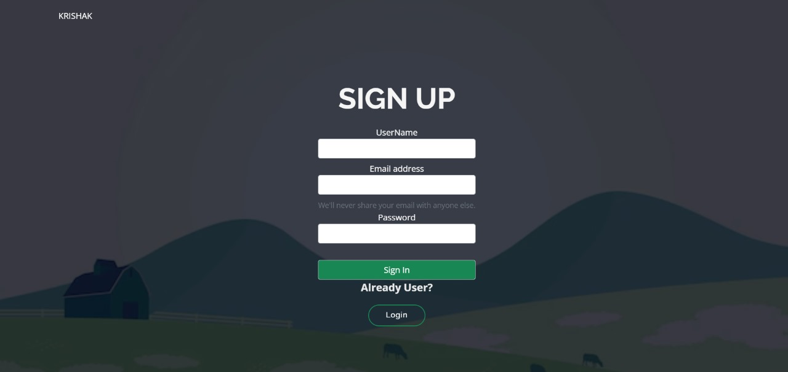
    - Test Case Name: User Login
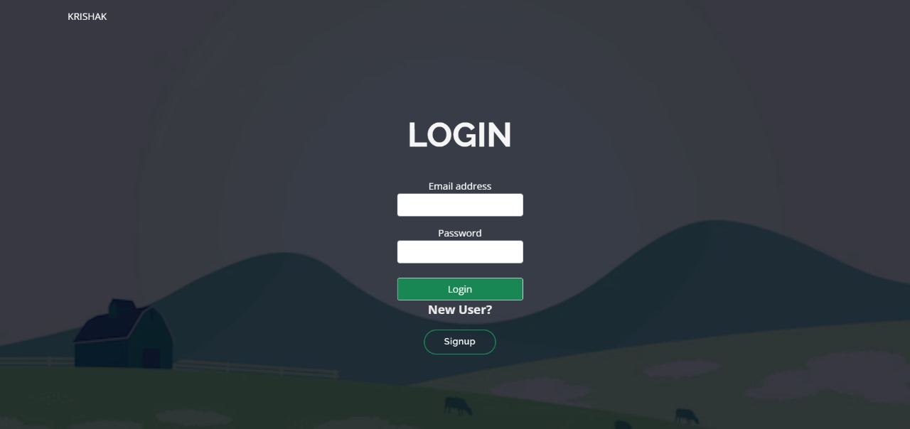
    - Test Case Name: Adding Clients
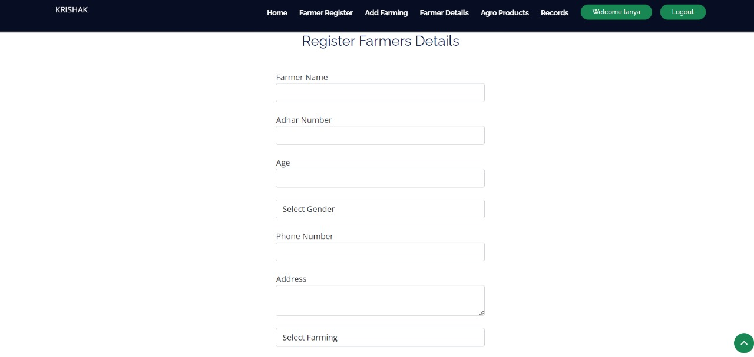
    - Test Case Name: Adding item
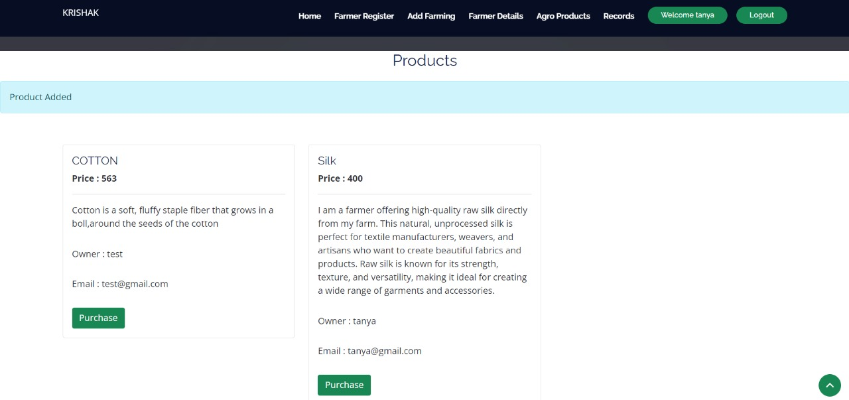
    - Test Case Name: Farmer Details
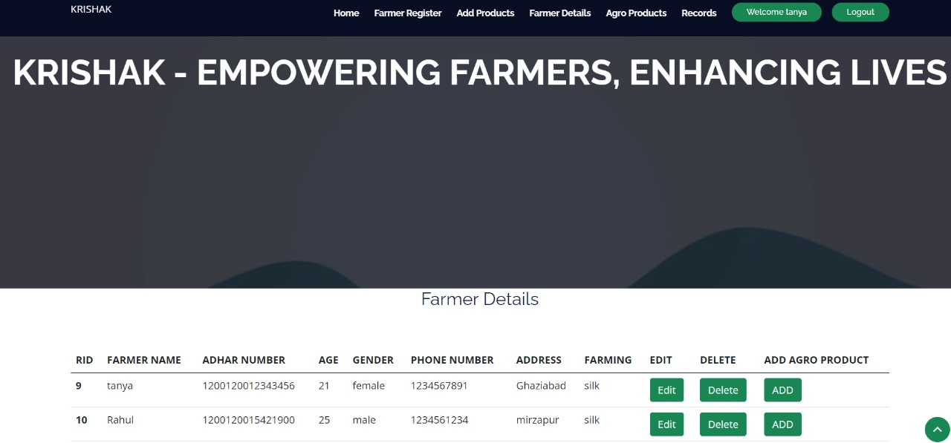
    - Test Case Name: Making Purchase

    - Test Case Name: Profile Update

  - Test Cases
Test Case ID | Test Scenario | Steps to Execute | Expected Result
TC01 | Validate User Sign-up functionality | 1. Navigate to the Sign-up page.  2. Enter valid phone number, name, email id, etc.  3. Click "Sign Up." | User account is created successfully.
TC02 | Validate User Login with valid credentials | 1. Navigate to the Login page.  2. Enter valid phone number and OTP.  3. Click "Log In." | User is logged in and redirected to the dashboard.
TC03 | Validate User Login with invalid credentials | 1. Navigate to the Login page.  2. Enter valid phone number but invalid OTP.  3. Click "Log In." | Error message displayed: "Invalid OTP."
TC04 | Verify adding a new item in equipment listing | 1. Navigate to "Add Product" page.  2. Enter valid item details (name, price, quantity).  3. Click "Add." | Item is added successfully and visible in the "Product" list.
TC05 | Verify booking request | 1. Navigate to "Product details" page.  2. Select equipment.  3. Request booking. | Owner notified, request pending
TC06 | Payment Processing | Complete transaction via integrated gateway. | Payment confirmed, receipt generated.
TC07 | User Messaging | Send message to equipment owner. | Message successfully delivered.
TC08 | Review & Rating | Submit review for rented equipment | Review is posted and visible
TC09 | Equipment Search & Filter | Apply filters on listing page | Relevant equipment displayed
TC10 | Validate dashboard displays accurate metrics | 1. Navigate to Dashboard.  2. Check Product details, Farmer details. | Dashboard displays correct and real-time data.

- Resouce and Environment Needs

  - Testing Tools
- Selenium WebDriver: For automating web-based testing.
- Chrome Driver, Gecko Driver: For browser-specific testing.
- TestNG: To manage test execution and generate reports.
- Eclipse or IntelliJ IDEA: IDEs for writing and managing Selenium scripts.
  - Test Environment
- Hardware Requirements:
- Operating System: Windows 10 or higher.
- RAM: Minimum 8GB.
- Processor: Intel Core i5 or higher.
- Software Requirements:
- Google Chrome, Mozilla Firefox, and Microsoft Edge (latest versions).
- Stable internet connection.
- Test URL:
- Krishak
- Terms/ Acronyms
Term/Acronym | Definition
AUT | Application Under Test
QA | Quality Assurance
Selenium WebDriver | A tool for automating web browser interactions
TestNG | A testing framework for Java applications
ChromeDriver | A driver for automating tests on Chrome
GeckoDriver | A driver for automating tests on Firefox
Regression Testing | Testing to ensure changes do not break existing functionalities

